Magnetic Declination
SLC UT = 11° 4’

What is Magnetic Declination
2 “Norths” exist. True North (north pole) and Magnetic North (Magnetic pole)
Magnetic Declination = Difference between True North and Magnetic north.
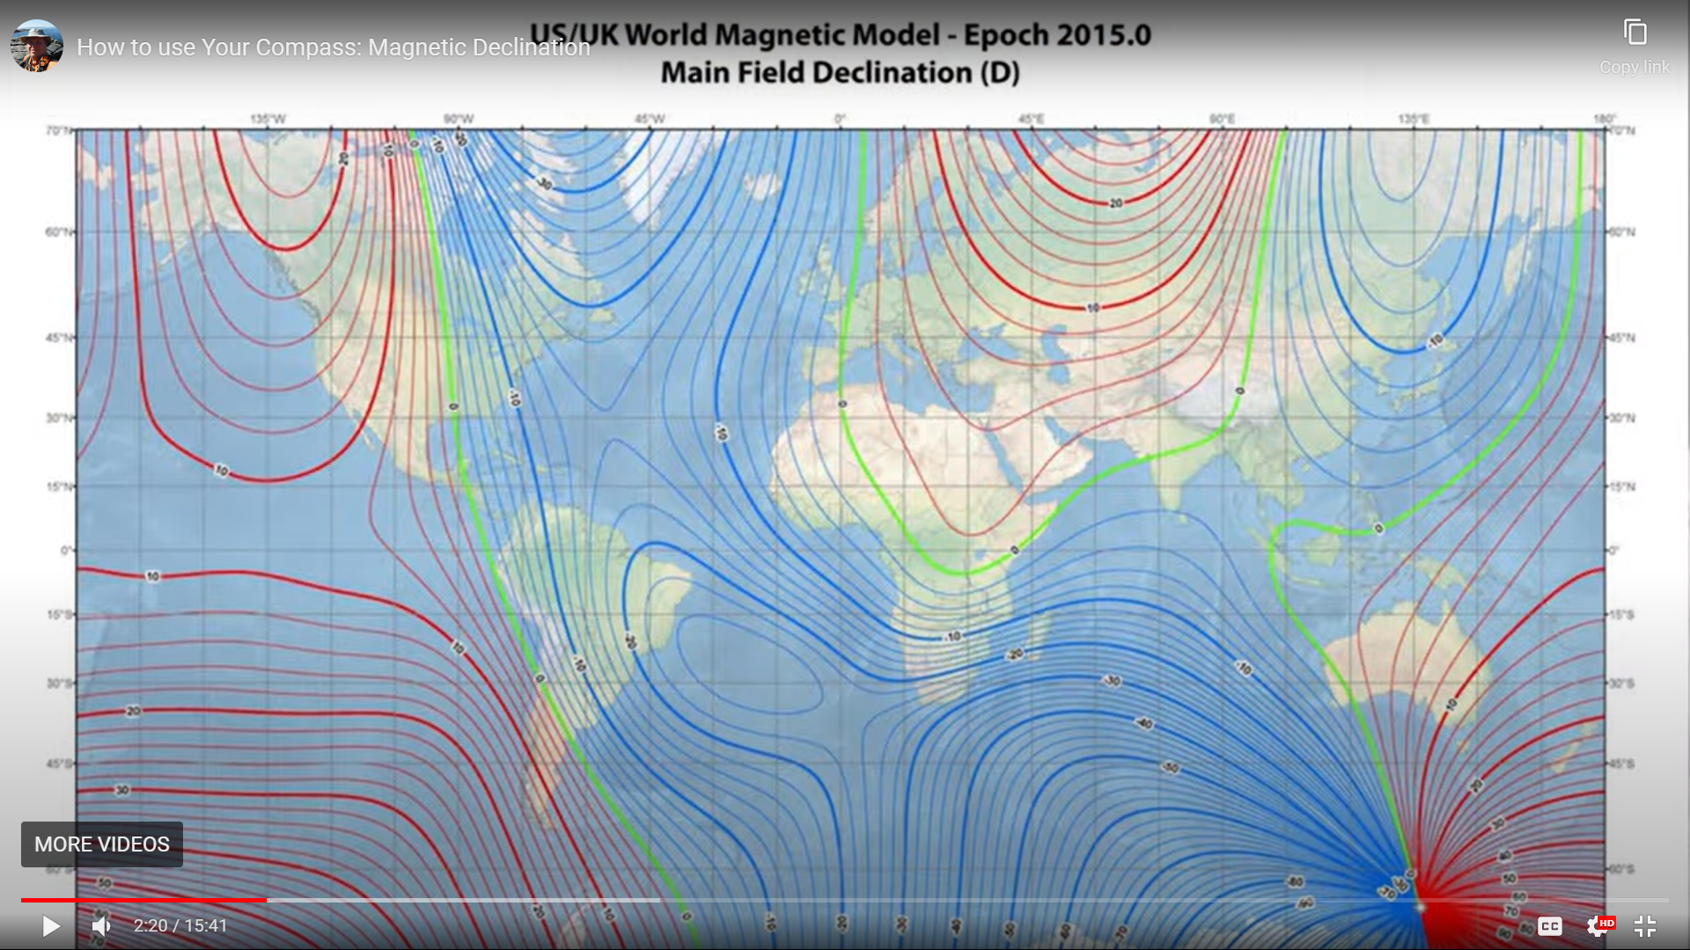
Image showing lines of magnetism. (Declination)
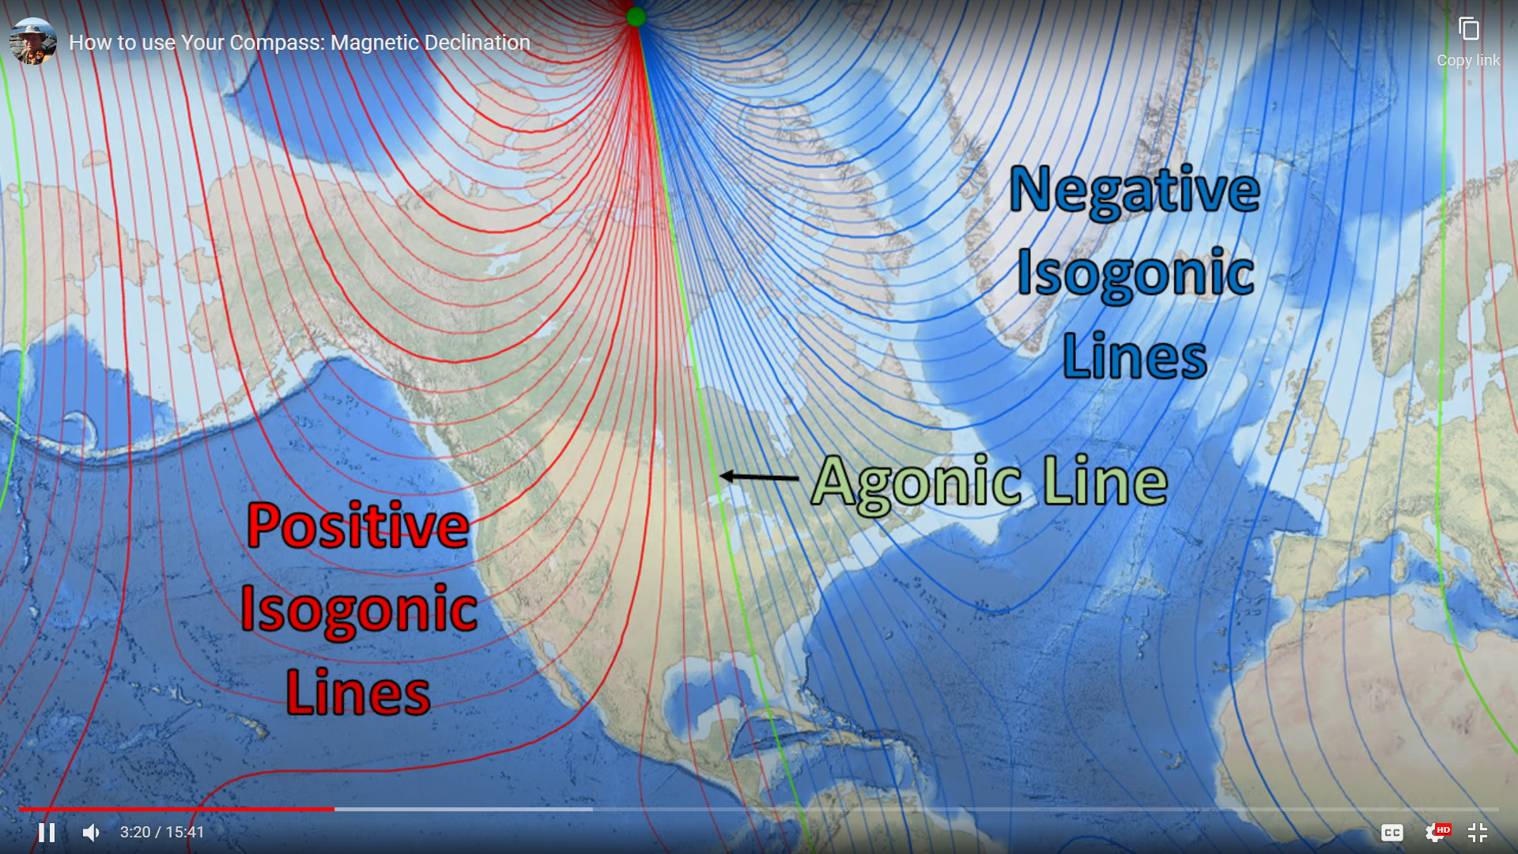
Showing Isogonic (magnetic lines)

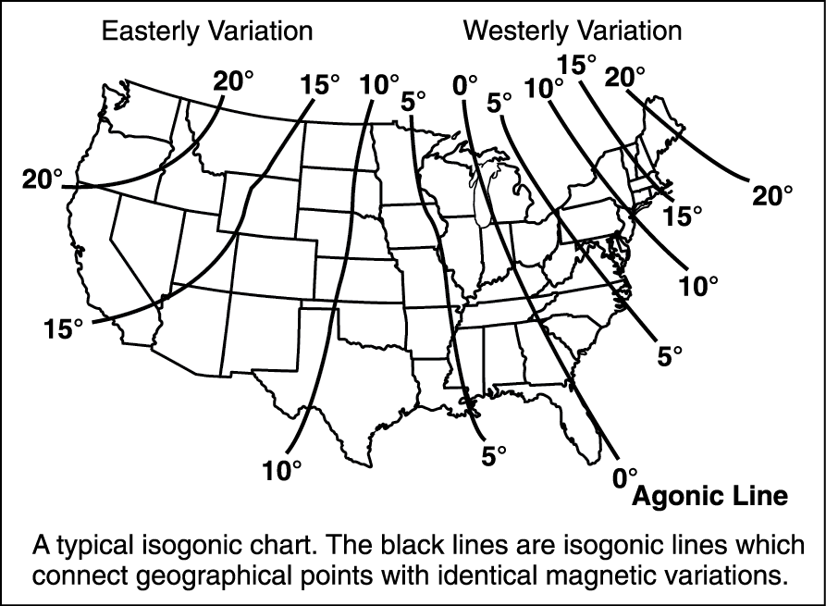
Isogonic Chart for N. America – 2022
- Lines that lean left (west) are Western Declination lines
- Lines that lean right (east) are Eastern Declination lines
- UT has Eastern Declination of 11° 4’
- 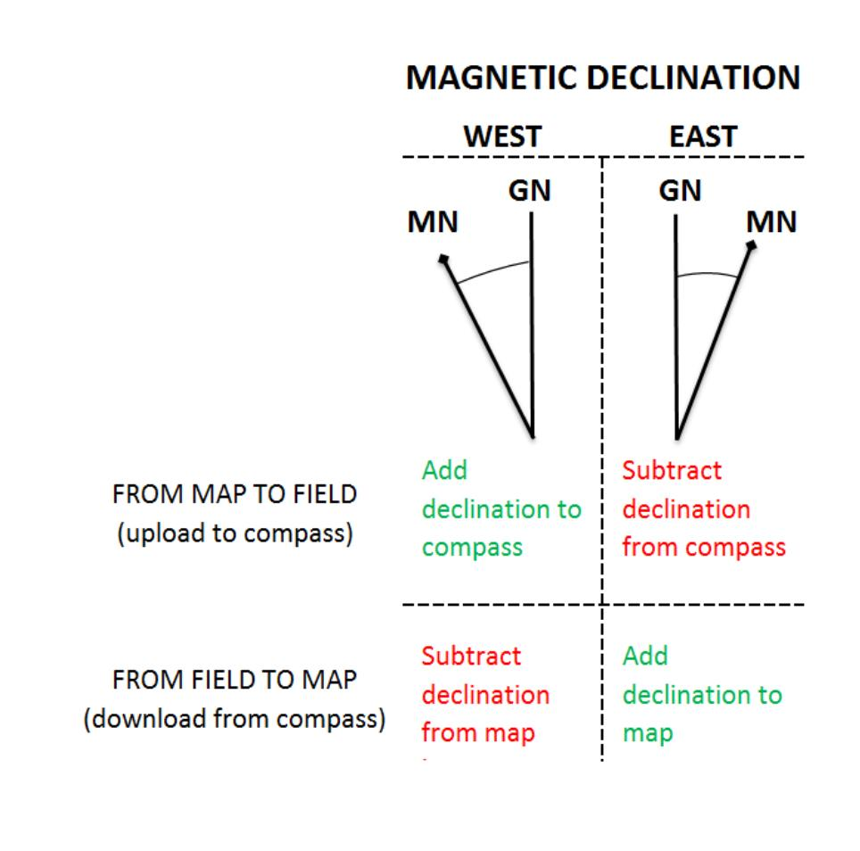

3 Methods of determine bearings with declination.
- Adjust the compass for declination
- Add or subtract declination for each bearing.
- Adjust map for declination

Adjust the compass for declination
- Point the compass baseplate in the direction of travel.
- To set declination.
  - Can use the declination diagram at the bottom of the map.
    - Rotate the bezel in the direction shown.
  - For EAST declination: (if your magnetic is East of True North – Positive inclination)
    - Subtract declination from North and set bezel
  - For West declination: (if your magnetic is West of True North – Negative inclination)
    - Add declination to North and set bezel

Add or subtract declination for each bearing.

To Calculate declination:

To transfer Magnetic (Observed) Headings to TN map Bearings
  - Direction bearing + declination = TN map heading
    - For EAST declination: (Positive inclination), Add declination to observed heading. Use a positive number in the formula.
    - For West declination: (Negative inclination), Subtract declination from observed heading. Use a negative number in the formula
Example: If you want to go to a heading of 50° magnetic at SLC Utah (11° 4’)
  - Direction bearing + declination = TN map heading
  - (50° + 11°) = 61° True North (on map)
Example: If you want to go to a heading of 50° magnetic at New York City (-13°)
  - Direction bearing + declination = TN map heading
  - (50° - 13°) = 37° True North (on map)

To transfer TN map Bearings to Magnetic (Observed) Headings.
  - TN map heading – declination = Direction Bearing
Example: If you want to go to a Bearing of 50° TN at SLC Utah (11° 4’)
  - TN map heading – declination = Direction Bearing
  - (50° - 11°) = 39° Magnetic
    - Rotate the compass bezel to 39°
    - Point marching arrow at a landmark with compass needle on and move in that direction for the required distance.

3. Adjust MAP for declination (Easiest Method)

Process:
- Check the diagram for accuracy. Measure it with a protractor.
- Get a nice long wide ruler. Line up with Magnetic declination diagram
- Draw lines on each side of the ruler, and continue across the map.
- Now you are ONLY using Magnetic compass lines on the map, NOT True North lines.
- All measurements are now correct and no calculation is required.

Map Bag Contents
- Map(s) – Marked with magnetic lines (drawn on)
- Note Pad
- Pens and pencils w/eraser
- Hiking protractor
- Ruler/Straight edge
- Instructions
- Map Cover - Waterproof

